Pollinators to Look for in your backyard!

How many do you see?
Use tally marks to keep track!
Butterflies:

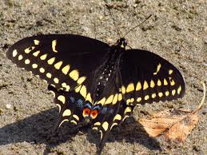 Black Swallowtail ____________

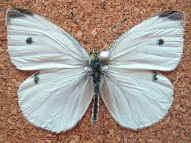 Cabbage White ____________

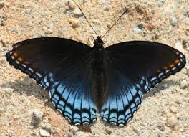Red Spotted Purple ____________

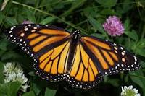 Monarch ____________

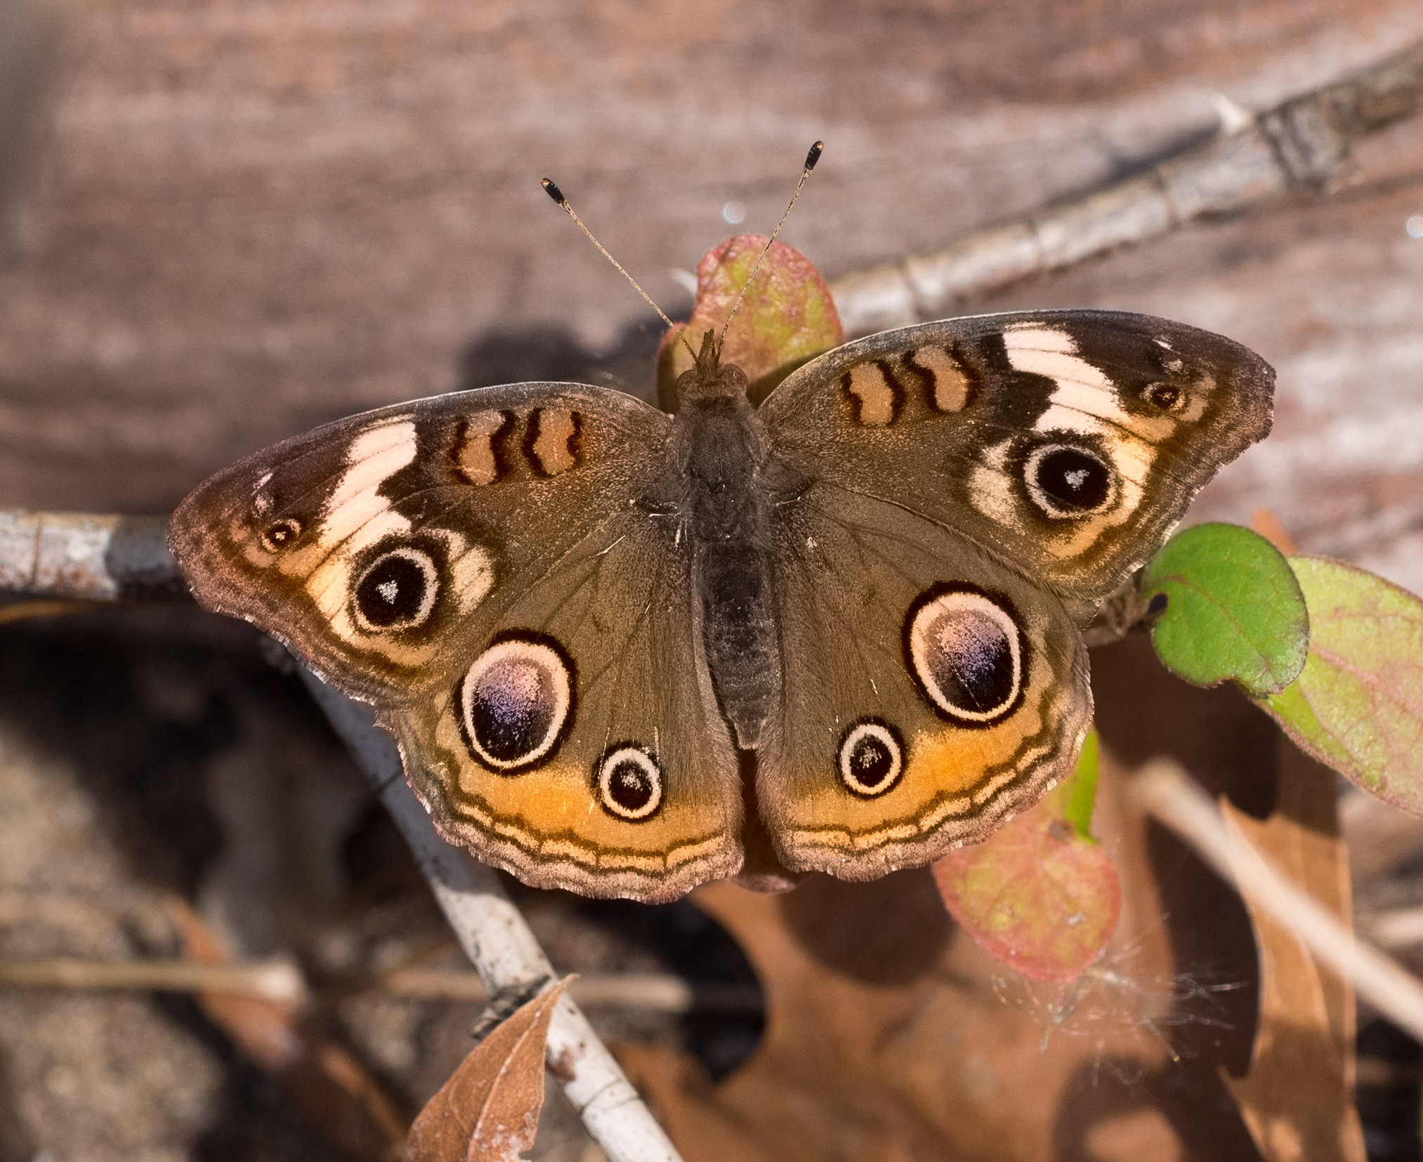 Buckeye ____________

Birds:

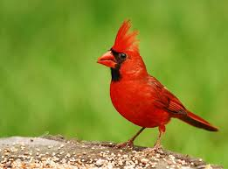Northern Cardinal ____________

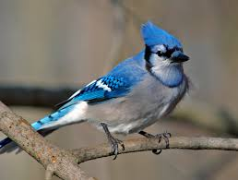 Blue Jay ____________

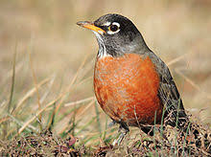 American Robin ____________

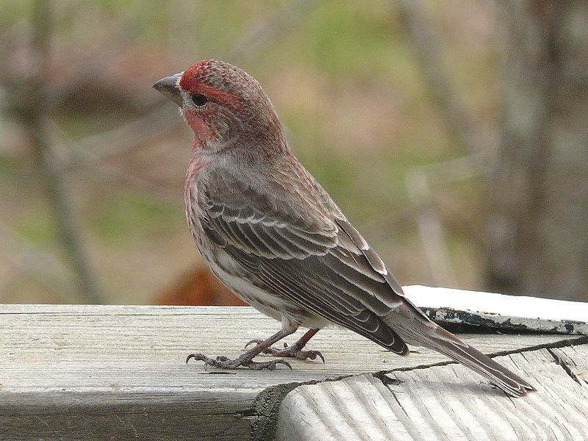 House Finch ____________

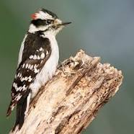 Downy Woodpecker ____________

Bees and Wasps:

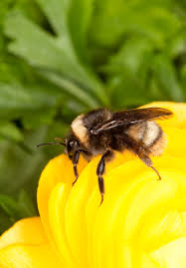 American Bumblebee ___________

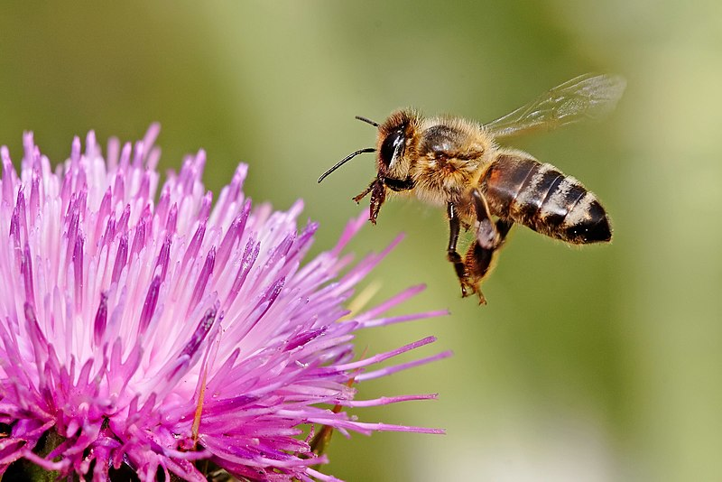 Honey Bee _________

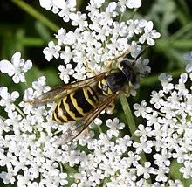 Yellow Jacket _________

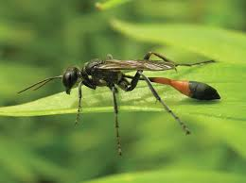 Thread Waisted Wasp ___________

Trees and Flowers:

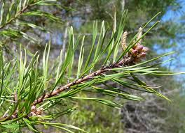 Virgnia Pine ____________

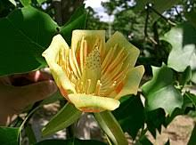 Tulip Poplar ____________

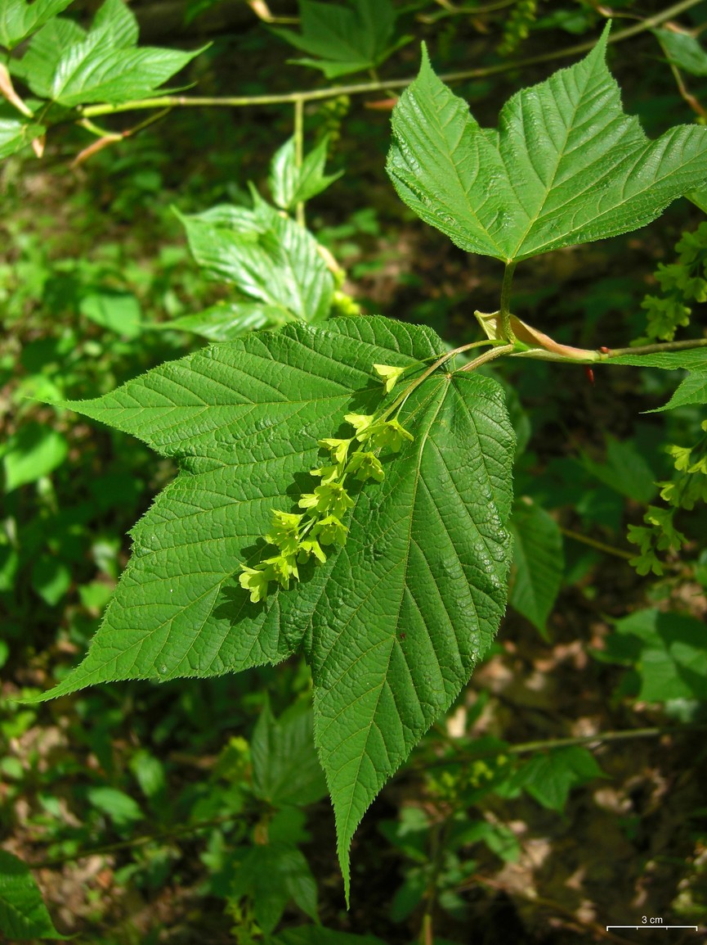 Striped Maple ____________

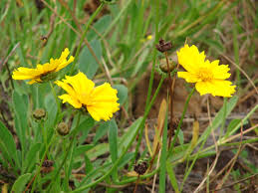 Lanceleaf Coreopsis ____________

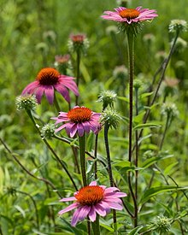 Eastern Purple Cornflower ___________

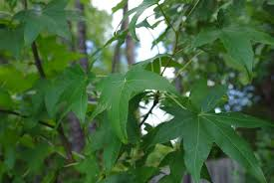 Sweet Gum Tree ___________

